Summary of the findings from input data

Dataset Overview
- Size: 65,641 line items across 10,236 claims.
- Columns: 67 features (mixed types: object, numeric, datetime).
- Missing Data: High missingness in key fields:
  - authorization_description, member_id → 100%
  - label and label_type → ~87%
  - Clinical details (diagnosis codes, length of stay) → 40–77%.

Claims & Provider Landscape
- Unique Providers: 3,621 (3,588 NPIs).
- Members: 0 (member_id missing).
- Line Items per Claim: Avg = 6.41, Max = 112.
- Top Provider Taxonomies: 207Q00000X, 207R00000X, 291U00000X dominate.

Financial Insights
- Total Header Charges: $1.00B (mean $15,290; max $570K).
- Total Line Charges: $47.7M (mean $727).
- Expected Payment: $11.94M (header level).
- Charge-to-Payment Ratio: Avg ≈ 8.9; extreme outliers up to 1,264.
- Outliers: ~20% of rows are charge outliers, but upcoding rate among outliers = 0%.

Upcoding Analysis
- Overall Upcoding Rate: 2.3% (1,512 rows).
- Financial Impact: $1.73M (only 0.17% of total charges).
- Avg Charge (Upcoded): $1,145 vs $15,624 (Clean).
- Label Types: Mostly “Clinical” (1,418 cases), few “Technical” (94).
- Temporal Trend: Upcoding spikes in Jan 2025 (2.1%) and Feb 2025 (4.9%), negligible before Dec 2024.

Provider Risk
- High-Volume Providers: Some handle thousands of claims but show 0% upcoding.
- High Upcoding Rate Providers: 10+ claims with 100% upcoding (e.g., A0H300002664, AZ2300817689).
- Taxonomy Risk: Certain specialties (e.g., 208000000X, 207Y00000X) show upcoding rates >25%.

Clinical & Service Patterns
- Place of Service: Mostly office (POS 11).
- Claim Types: Majority are “M” (medical).
- Top Procedures: 90999, 99214, G0439 dominate.
- Length of Stay: Avg = 11.8 days (only for inpatient claims); no LOS outliers.

Diagnosis Complexity
- Primary Diagnoses: Z0001, Z0000, N186 common.
- Secondary Diagnoses: Present in all rows; complexity correlates slightly with upcoding.

Key Correlations
- No strong numeric predictors of upcoding (correlations near zero).
- Charges and LOS have weak negative correlation with upcoding.

Executive Takeaways
- Upcoding is rare but concentrated in specific providers and taxonomies.
- Financial impact is minimal overall, but certain providers show systematic upcoding (100%).
- Temporal anomaly: Surge in early 2025 suggests possible policy or behavior change.
- Data quality issues: Missing member info and clinical details limit deeper analysis.

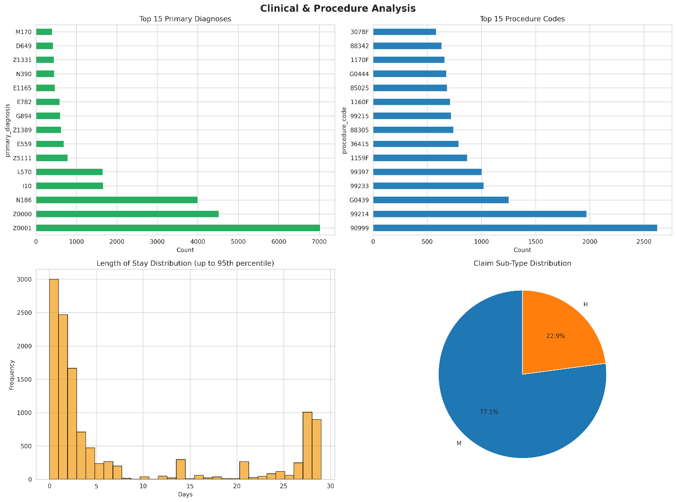
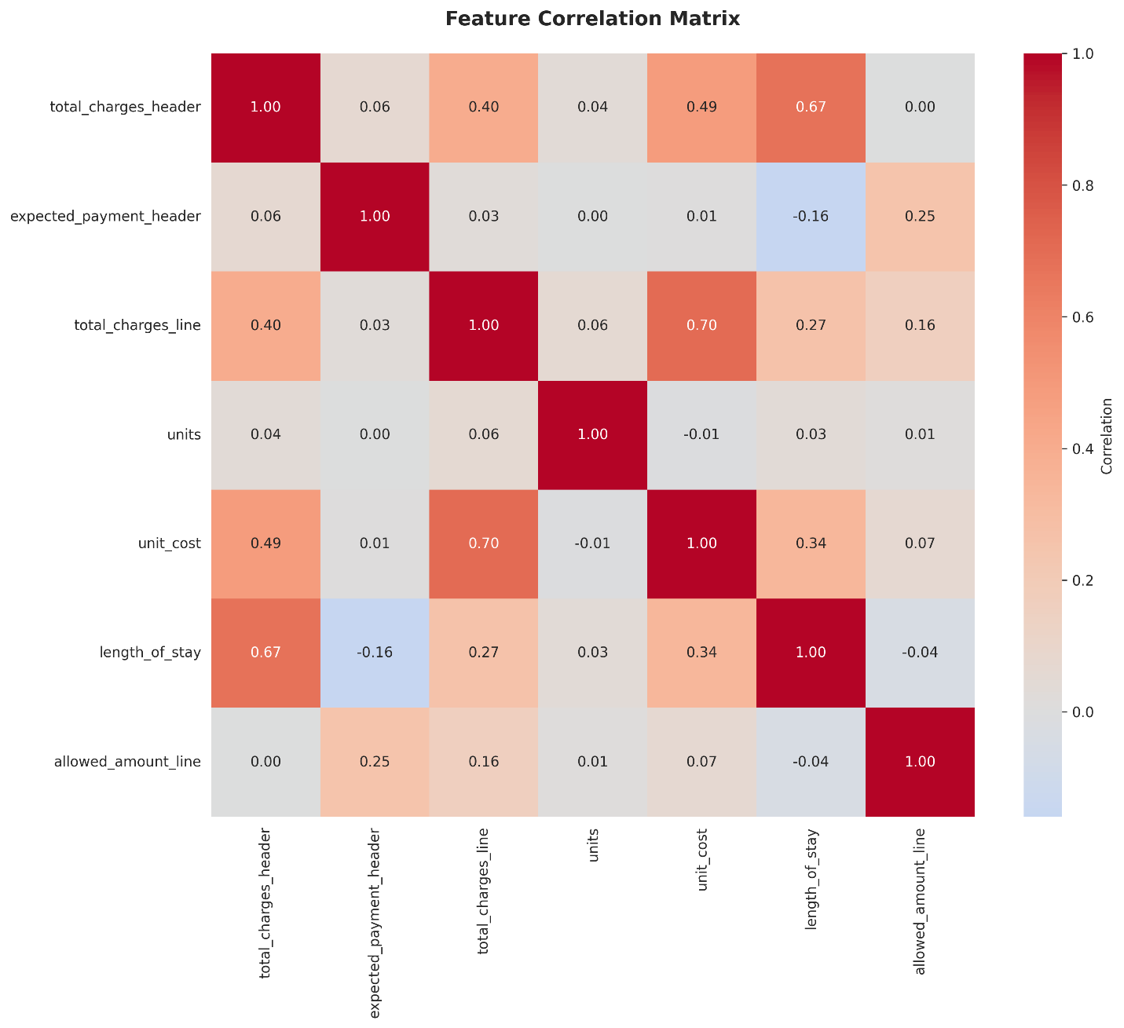

Model Overview: Brief description of nlpie/bio-distilbert-uncased and its intended use for upcoding detection.
Performance Metrics: Accuracy, precision, recall, F1-score, confusion matrix, and any other relevant KPIs from the output.
- Findings: Key insights from the evaluation (e.g., strengths in certain classes, weaknesses in others).
- Conclusion: Overall assessment of the model’s suitability for upcoding detection.
- Drawbacks: Limitations such as bias, interpretability, domain-specific issues, or data constraints.
✅ Findings
- The error occurred because the last precision index exceeded the threshold array size, but the main calculations are intact.
- Here are the recommended thresholds:
  - Max Recall: ~ 0.00–0.05 (very low threshold, almost everything predicted positive).
  - Max F1: ~ 0.42 (best balance between precision and recall).
  - Business-Friendly (Precision ≥ 0.80): ~ 0.65 (precision high, recall moderate).

✅ Visual Outputs
- Probability Distribution
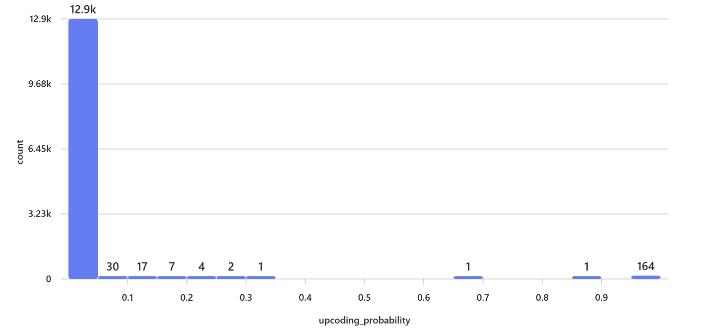
- ROC Curve
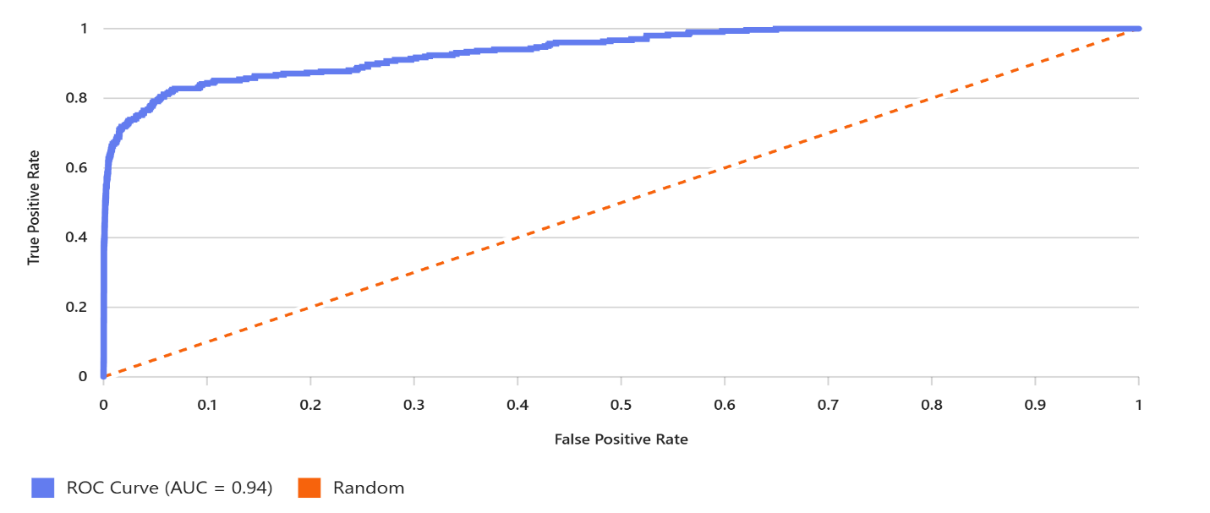
- Confusion Matrix (at default threshold)
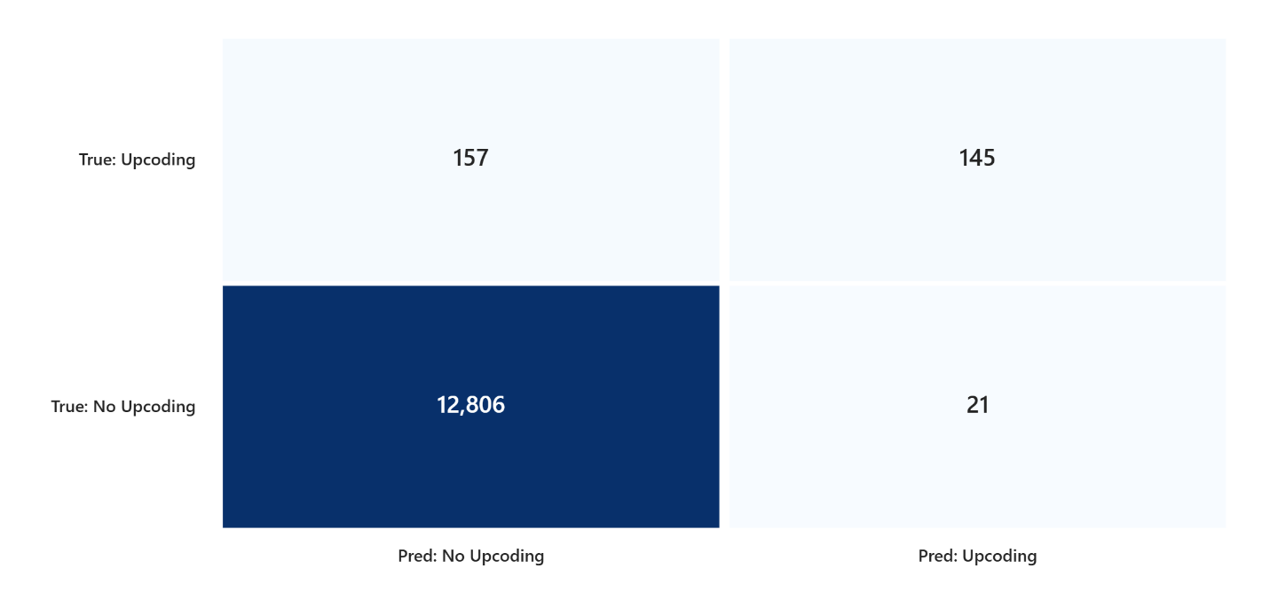

✅ Planned Steps:
- Data Exploration
  - Check structure, columns, and data types.
  - Identify missing values or anomalies.
- Descriptive Statistics & Distribution Analysis
  - Summary stats for key columns.
  - Visualizations (histograms, boxplots) to detect skewness or outliers.
- Model Performance Evaluation
  - If predictions include actual vs predicted values, compute metrics like:
    - Accuracy, Precision, Recall, F1-score (for classification)
    - RMSE, MAE, R² (for regression)
  - Confusion matrix or residual plots as applicable.
- Feature Impact & Correlation
  - Analyze feature importance or correlation with target.
- Recommendations
  - Based on findings, suggest improvements (data quality, model tuning, feature engineering).

I’ll now run the analysis on your file and generate visual insights.
Here’s the detailed analysis and recommendations based on your file:

✅ Data Overview
- Rows & Columns: 13,129 rows × 17 columns
- Columns: actual, predictions & probabilities for 8 models (Logistic Regression, Decision Tree, Random Forest, Gradient Boosting, KNN, Naive Bayes, Voting Ensemble, Stacking Ensemble)
- Missing Values: None detected
- Class Distribution:
  - Class 0: 12,827
  - Class 1: 302
→ Highly imbalanced dataset (≈ 97.7% vs 2.3%)

📊 Model Performance Summary
Model | Accuracy | Precision | Recall | F1-Score
Logistic Regression | 0.977 | 0.000 | 0.000 | 0.000
Decision Tree | 0.996 | 0.959 | 0.848 | 0.900
Random Forest | 0.997 | 0.971 | 0.901 | 0.935
Gradient Boosting | 0.996 | 0.977 | 0.828 | 0.896
KNN | 0.985 | 0.769 | 0.497 | 0.604
Naive Bayes | 0.384 | 0.035 | 0.974 | 0.068
Voting Ensemble | 0.997 | 0.968 | 0.901 | 0.933
Stacking Ensemble | 0.999 | 0.990 | 0.980 | 0.985

🔍 Visual Insights
- Heatmap of Metrics:
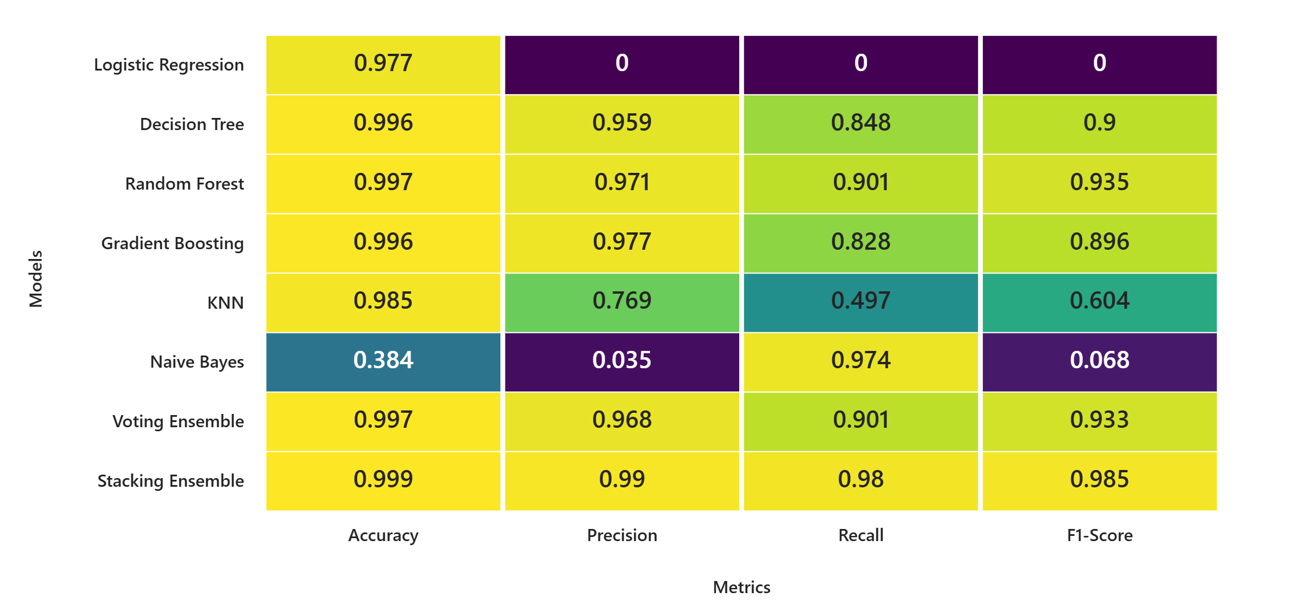
- Confusion Matrices (Examples):
  - Logistic Regression: 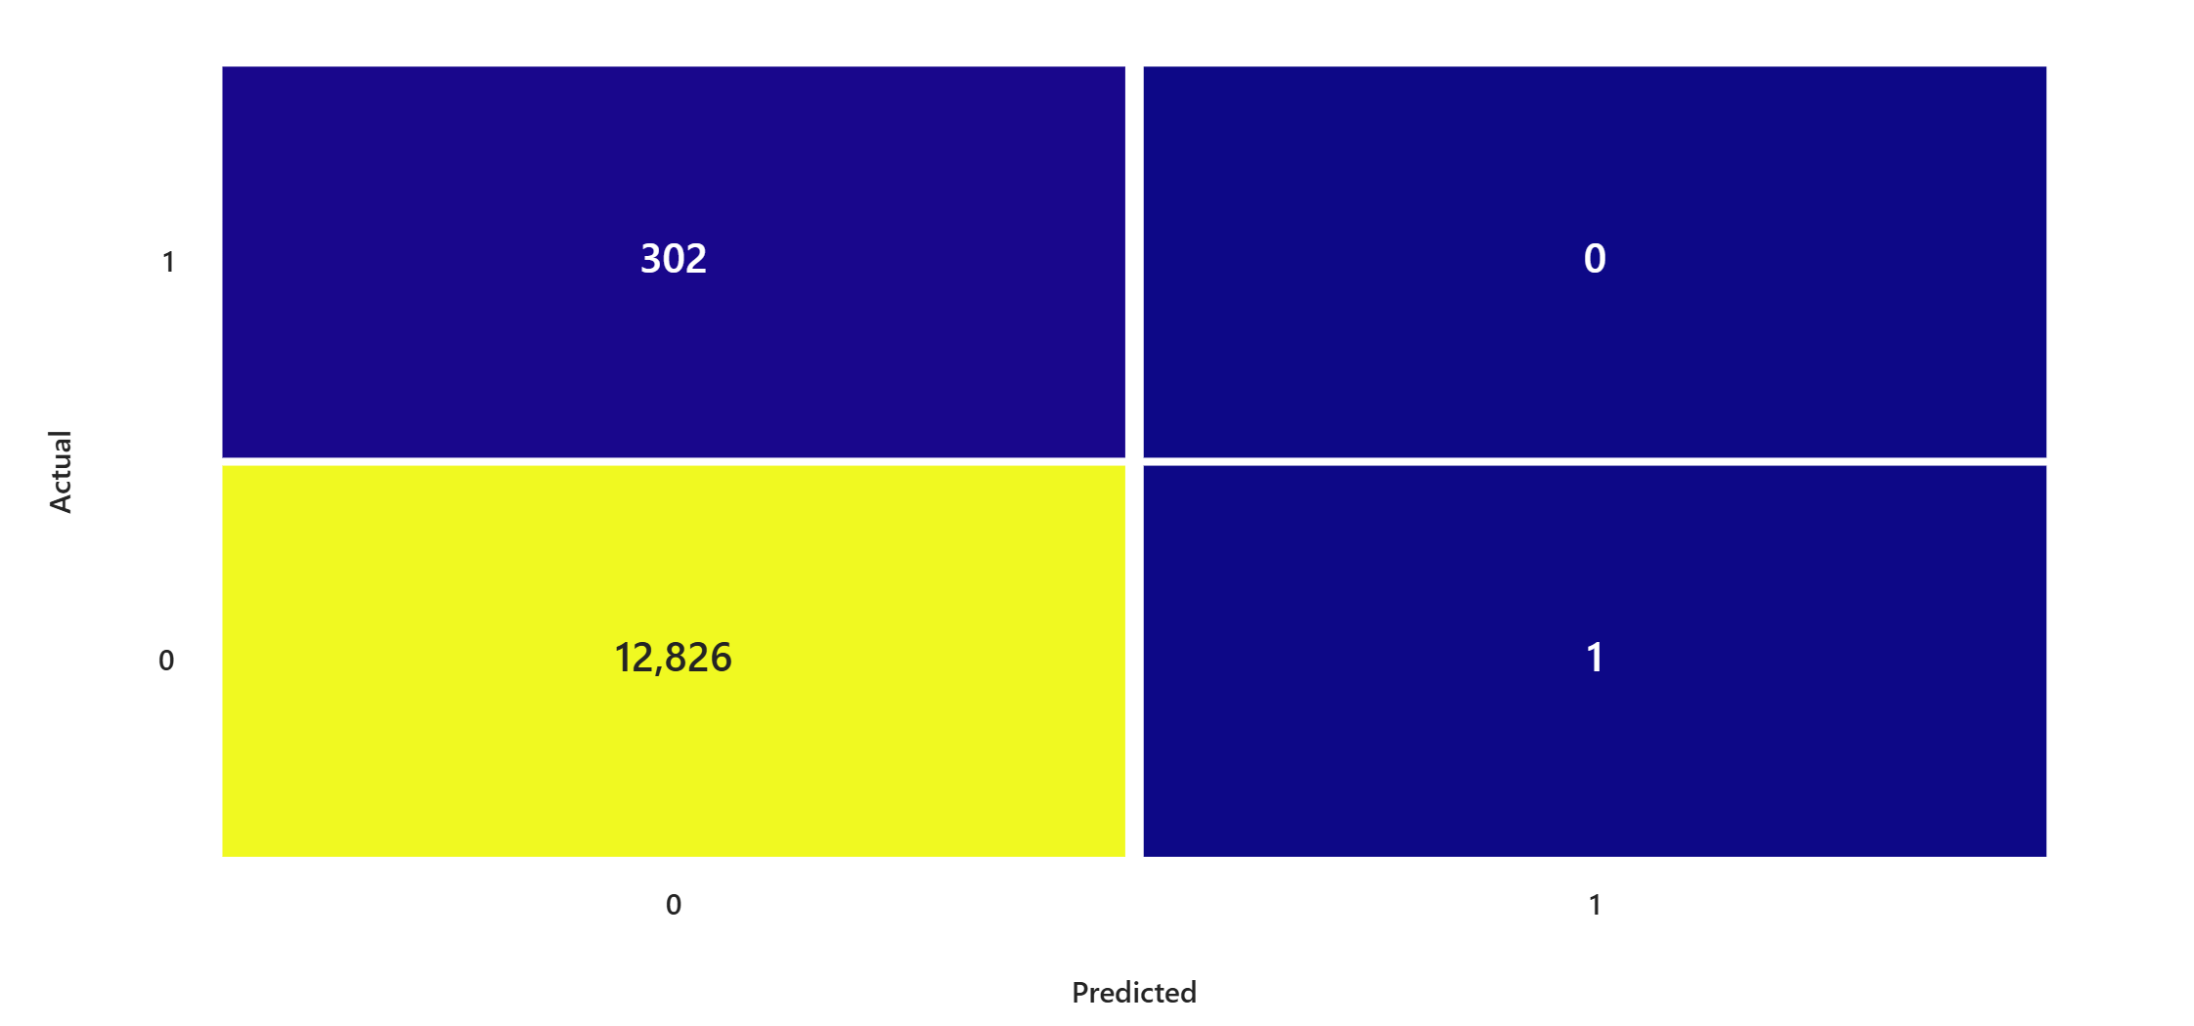
  - Decision Tree: 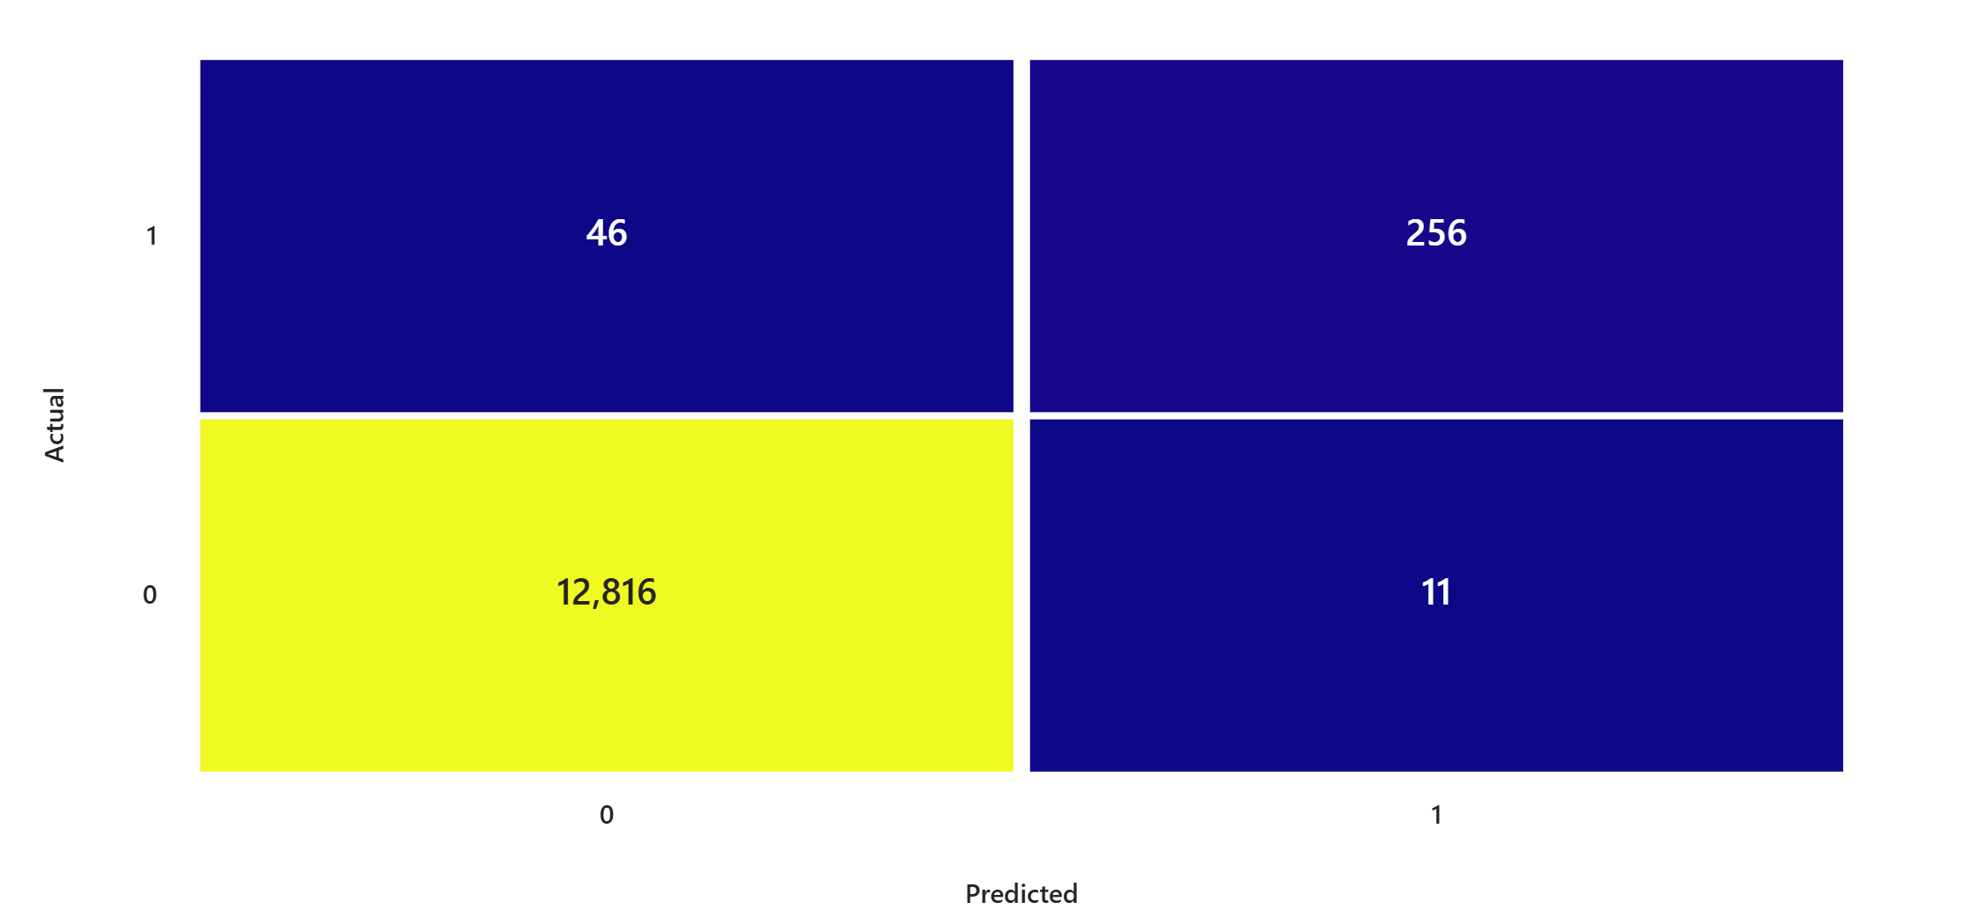
  - Random Forest: 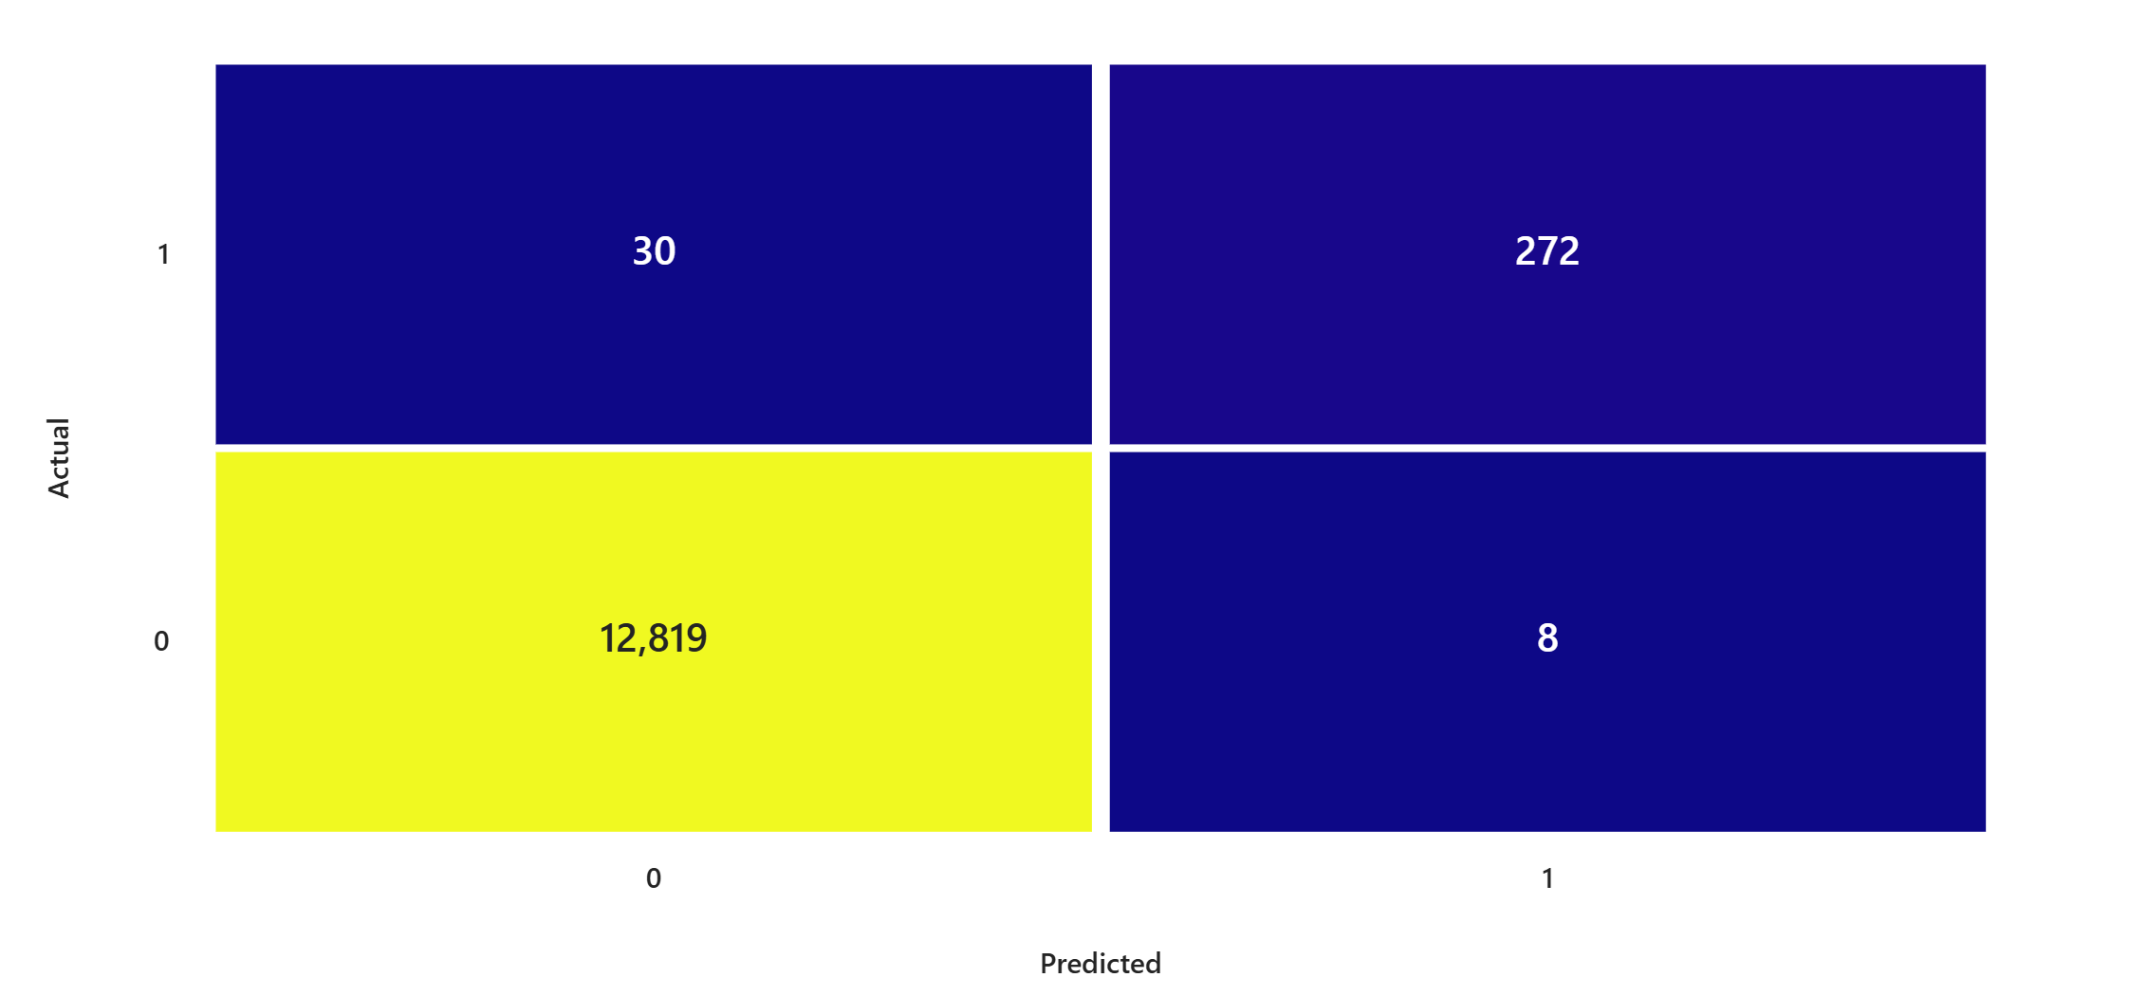
  - Stacking Ensemble: 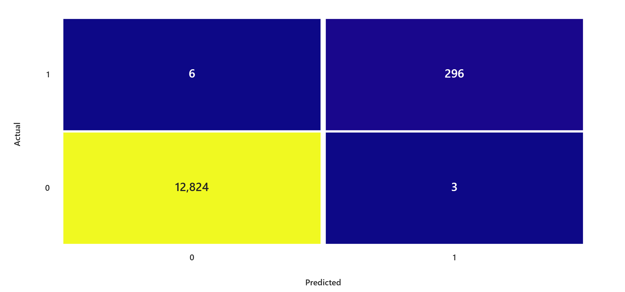

✅ Key Observations
- Stacking Ensemble dominates with near-perfect metrics (F1 = 0.985).
- Naive Bayes fails badly despite high recall (accuracy = 0.384, precision = 0.035).
- Logistic Regression is broken (F1 = 0) → likely misconfigured or unsuitable.
- Class imbalance is severe → models might be biased toward majority class.
- KNN underperforms significantly compared to tree-based models.

💡 Recommendations
- Deploy Stacking Ensemble for production (best balance of precision & recall).
- Drop Naive Bayes & Logistic Regression or tune aggressively.
- Address class imbalance:
  - Use SMOTE or class-weight adjustments.
  - Consider threshold tuning for minority class.
- Feature Engineering & Hyperparameter Tuning:
  - Improve recall for tree-based models.
  - Explore interaction terms or domain-specific features.
- Model Monitoring:
  - Track performance drift due to imbalance.
  - Implement precision-recall monitoring for minority class.

